**LP7 (Test on Edge Browser)**

**1.Verify the Header-**

(a) Logo should redirect to the correct link.

NO, it redirects to the new tab but same link

(b) Logo link should open in a new tab.

No. it is not open on another new tab.



**2.Verify the Footer-**

(a) Verify redirection of Links and content.

Header links is not working otherwise all is working.

(b) Verify social icons' redirection.

No social icon presents in the footer.



**3.Verify Correct Favicon- Favicon should be the same as it is on the client's live website.**

There is no Favicon present on the given website.

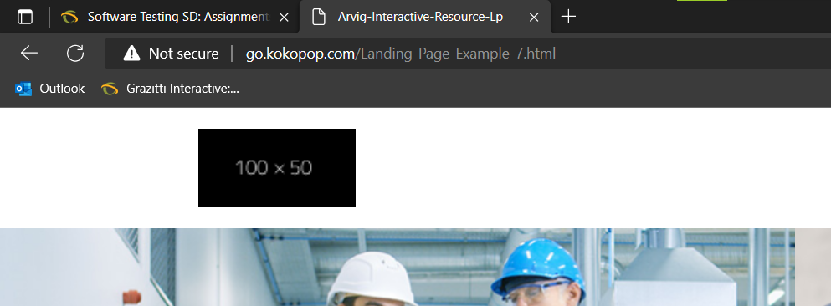

**4.Verify the Font-family- Verify font family is consistent throughout(unless special   requirement by client).**

In this the paragraph alignment is not correct.

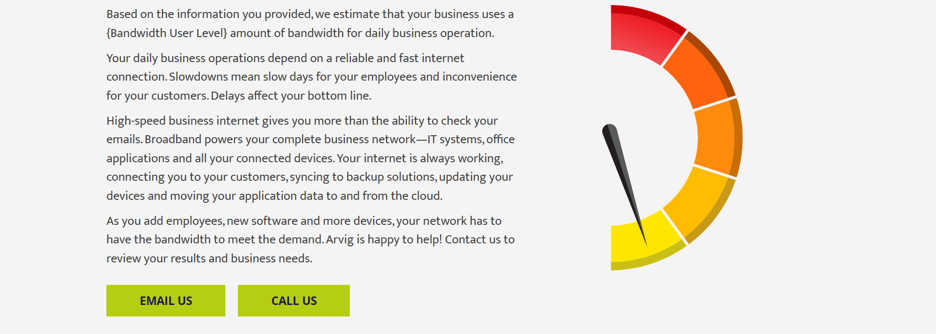

**5.Verify the redirection of links-**

(a) All CTAs, links and icons should redirect to correct pages.

Some header and all footer is working fine, excepts – Service and Support CTA on the header.

(b) Add note to developer if # is used for links.

Remove all the ‘#’ from the used limks.

**6.Verify the Spacing - Verify Spacing and alignment of the page should not break.**

Spacing and Alignment of the page is not break.

**7.Verify Form-**

(a) Verify alignment and spacing of form.

(b) Verify * is used for Mandatory Fields.

(c) Verify it is showing correct error messages.

No, Form is here in the given Link.

**8.Verify Thank you message after submitting form- If Required.**

No message is shown as Thank You.

**9.Verify Landing page on cross browsers- Google Chrome, Firefox, Internet Explorer and MAC (Safari).**

The website is working on the Google, Firebox, Edge and Chrome.

**10.Verify Responsive- Verify it on iPhone and iPad on simulator or live device.**